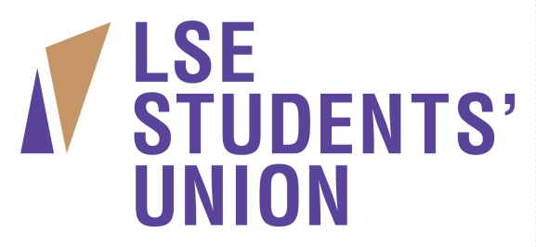

Commercial Administration Assistant

Accountable to: Bars and Catering Manager

Responsible for: Providing administrative support to the Bars, Catering and Events Managers

Hours: 37 hours

Location: Central London (LSESU)

JOB PURPOSE

- To assist the Bars and Catering Manager by providing administrative support, diary management, ad hoc research and senior management reporting support.
- To support the administration of the Bars, Catering and Events departments.
- To create and prepare documentation and develop administrative process to increase efficiency.
- To supervise and co-ordinate commercial maintenance/ordering
- To help the relevant manager with HR and recruitment processes

KEY RESPONSIBILITIES

Bars and Catering Manager

- To provide administrative support for Bars and Catering Manager
- To offer support in regular and irregular meetings for Bars and Catering Manager throughout the year, ensuring the administration and follow up of action points
- Ensure that all materials for meetings are prepared in a timely manner.
- To implement and maintain an efficient filing system.
- To assist with the creation of monthly sales and product reports for Senior Management and Trustees.
- To develop current administration process to increase efficiency
- To assist in the delivery/recording of commercial staff TOIL.

Catering

- To assist with the general administration of the Catering Department.
- To ensure that the catering event schedule is accurately logged and the appropriate bar/catering manager or supervisor is updated prior to the event.
- To support the Catering Manager with ordering, monthly stock takes and maintenance.
- To provide ad hoc research as required.
- To assist with the financial administration of the Catering Department; supporting physical banking procedures and checks as required.
- To create and prepare documentation and develop administrative process to increase efficiency.

Bars

- To assist with the general administration of the Bars Department.
- To assist with the financial administration of the Bars Department; supporting physical banking procedures and checks, carrying out weekly invoice reconciliation.
- To support the Bar Manager with the administration of ordering and monthly stock takes.
- To manage the administration of lost property and handle customer queries
- To provide ad hoc research as required.
- To create and prepare documentation and develop administrative process to increase efficiency.
- To assist with student staff recruitment processes and contracts.
- To update EPoS and Total Control Premier.

Conference and Events

- To assist with the general administration of the Conference and Events Department.
- To assist with the financial administration of the Conference and Events Department; supporting physical banking procedures and checks, carrying out weekly invoice and account reconciliation.
- To draw up and administer External Event contracts and Deposit Holding Receipts.
- To assist the Conference and Events Manager with usage and sales reporting.
- To provide ad hoc research as required.
- To create and prepare documentation and develop administrative process to increase efficiency.

Operational development

- To contribute creatively to the Commercial Departments’ operational plans.
- To collate customer feedback to improve service delivery.

GENERAL DUTIES

In addition, all staff have the following general duties laid out in their job descriptions:
- To deliver and develop targets outlined in the Union’s strategic plan.
- To contribute and assist in the Union’s planning processes and the review of its performance and systems.
- Contribute to the positive and professional image of the Union and not act in such a manner as to bring the Union into disrepute.
- To observe and uphold the requirements of the Union Constitution and act at all times in accordance with policies including equality of opportunity.
- To undertake your own typing, filing, photocopying etc.
- Undertake any other duties appropriate for the grade and responsibilities of the post that may from time to time be reasonably requested.
- To take ownership of, their Induction, Personal Review Programme, Departmental Staff Meetings and be responsible for carrying out duties with full regard to the rules, policies and procedures and conditions of service contained in the Staff Handbook, and within Departments of the Students’ Union.
- A condition of employment is that all staff are expected to assist in key events throughout the year e.g. Freshers and welcome festivals and any other key event, including elections, if necessary. Staff are expected to portray a positive image, both internally and externally of the Students’ Union by displaying high standards of service, integrity, punctuality, politeness and professionalism.
- Where you are required to work with volunteers you must support and manage them appropriately in line with the Students’ Union volunteer policy
- Environmental consideration and environmental best practice is the responsibility of all Students’ Union staff
- Any other tasks that would be deemed suitable within this role as directed by line manager

