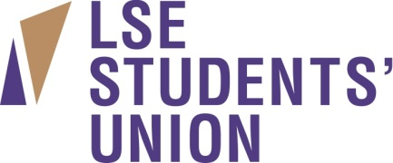

Female Gym Supervisor Salary: £18,311, 25 days holiday + additional
closure days and public holidays

The new LSE Students’ Union gym is looking to expand the team and recruit an additional Gym Supervisor as we continue to expand our services into the new academic year. Due to great student demand for female only fitness sessions and personal training, all applicants must be female.

The new gym opened this January and has been a gigantic hit with the student membership base due to its welcoming and non-confrontational environment, which caters to members from all over the world. It contains not only the most up to date equipment available, but also features the best performance section in the local area with multiple power racks, lifting platforms and Olympic disks.

As a Gym Supervisor you will be the main point of contact with our members and the face of the gym. Candidates must have practical experience working within gym or leisure facilities, be customer service focused and have a passion for helping others achieve their fitness goals and a better quality of life. Experience leading fitness classes is a must. There is an abundance of personal training opportunities and the facility will provide assistance in procuring clients.

You will need to be REPs Level 2 qualified or higher.

Responsibilities will include;

- Supervision of our members’ use of the gym floor.
- Working with both Gym Supervisors and student staff members to run the day to day operations of the gym.
- Providing member inductions, one to one and group training sessions.
- Maintaining safe function of all equipment in the facility.
- Conducting fitness classes.

Please visit http://www.lsesu.com/workforus/ for an application pack. If you have any queries about this role that are not covered in the documentation available below please contact Nick Turner on 020 7955 7161, email: N.Turner@lse.ac.uk
Closing date: 20/08/2014 at 5pm
Interviews: 25/08/2014

