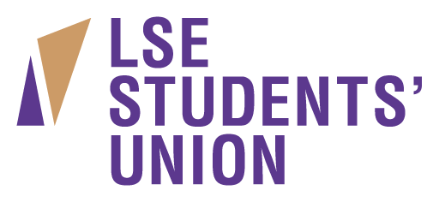

Social Media Assistant

Accountable to: LSESU Communications Coordinator
Salary: £8.80 per hour
Hours: 10 hours per week
Location: LSESU Saw Swee Hock Student Centre office

LSESU is looking for an organised student with great writing skills to join our Communications team on a part-time basis.

If your application is successful, you will work alongside other assistants in running our social media channels, and report to the Comms Coordinator.

This is the ideal opportunity for someone who’d like to be part of a dynamic and professional comms environment and is motivated by the idea of making the LSE experience accessible and rewarding to all students.

The ideal candidate will have:
- Fluent command of English
- Social media experience
- Demonstrable photography skills
- Filmmaking skills
- The ability to work without supervision

Responsibilities:
- Planning and delivering digital communications
- Working quickly and meeting tight deadlines
- Following comms guidelines
- Proactively reporting back to the Comms Coordinator
- Feeding back insights to the Comms team

A typical shift might include planning the coming week’s social media content, tweeting from a society event, and writing a blogpost about it.

The role is flexible (between 5 to 15 hours per week depending on your timetable) with potential to continue in the role into the next academic year, pending review.

LSESU is a progressive and reflective organisation that champions inclusion and diversity; we welcome applications from all students and are proud to offer work that can be adapted to suit our employees’ needs.

