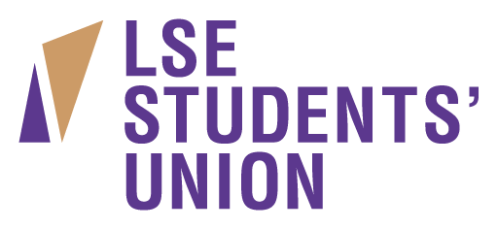

LSE Students’ Union represents and supports nearly 10,000 students who make up the driven and diverse student body at the London School of Economics. We provide social space and activities, a range of services and representation for our members. We are committed to providing excellent opportunities for our staff to learn and develop within their roles and offer an excellent environment in which you can grow in experience and skills. We are currently looking to fill one critical role in the Central Operations team.

If you are interested in taking on this exciting role in a progressive and forward thinking membership organisation we look forward to hearing from you.

Receptionist
Starting Salary: £18360pa, 25 days holiday + public holidays, Fixed Term 18 month contract

In January 2014 LSE and LSESU moved into the brand new purpose-built Saw Swee Hock Student Centre.
As the first point of contact for all visitors in this new student centre, you will enjoy working with a range of people and represent the Union in a positive, professional and friendly manor.
The ideal candidate will be proactive, self-motivated and demonstrate a high degree of initiative and determination. An outstanding approach to customer service is essential, in addition to great communication skills, and a good knowledge of Microsoft Office.

Responsibilities will include:
- Being the first point of contact for all students and external visitors attending the student centre
- Maintaining a professional and courteous service at the reception, ensuring all information is relevant and up-to-date
- Replying to enquiries through the main desk via email, phone, online website tools, written and face-to-face
- Tidy and maintain reception area
- Other ad-hoc administration duties as required by the Office Manager

A full application and information pack are available from http://www.lsesu.com/about/workforus/. Applications will only be considered on an official application form, along with a completed equal opportunities form.

If you wish to informally discuss the role, please get in touch with Natalie Bhantoa, Office Manager on n.bhantoa@lse.ac.uk or 0207 955 7158
Closing date: Monday 13th October 2014
Interviews: Wednesday 10th October 2014

