
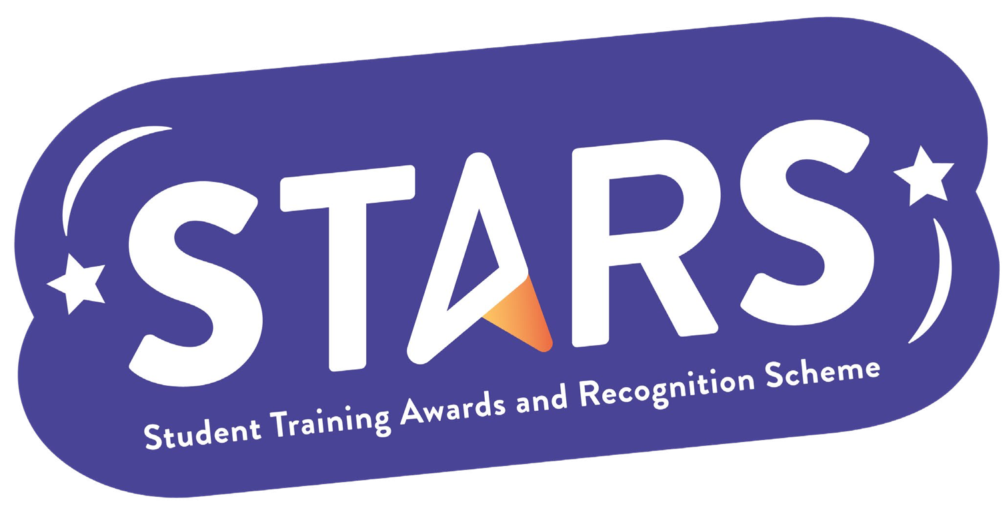

STARS – Collaboration

Name of Club/Soc: Insert your Club/Soc name

To achieve this badge, you will need to complete at least 2 of the criteria.
Criteria | Description  (Please describe how your group has met this criteria) | Evidence  (Please include photos, screenshots, social media posts, advertisements etc.)
Collaborate on an activity/event with another LSESU Club/Society from a different group category
Collaborate with an external organisation to host an event/initiative that benefits your members (e.g. speaker event or networking activity)

Receive a sponsorship from an LSE department or external organisation

