
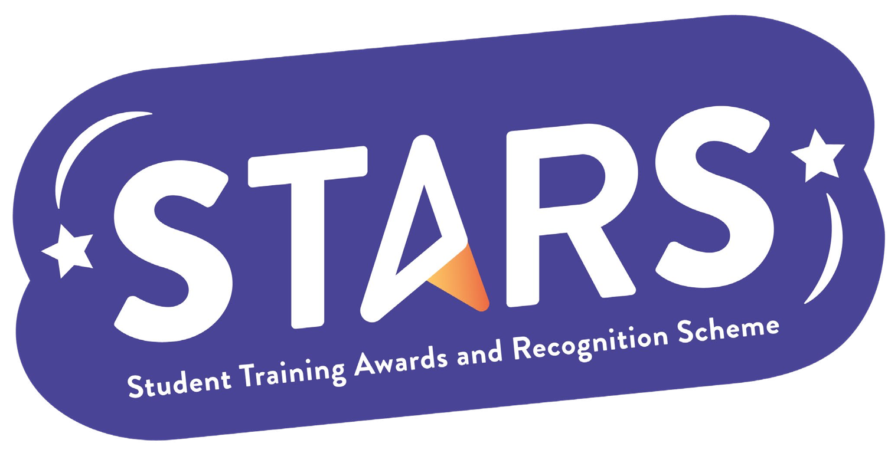

STARS – Community

Name of Club/Soc: Insert your Club/Soc name

To achieve this badge, you will need to complete at least 2 of the criteria.
Criteria | Description  (Please describe how your group has met this criteria) | Evidence  (Please include photos, screenshots, social media posts, advertisements etc.)
Facilitate at least two alumni engagement opportunities that connect current members with past members
Host at least one social event per month from 1st October to 31st March, include at least two non-drinking socials
Increase membership by 10% compared to the previous academic year

Run an end-of-year event to recognise and celebrate members

