
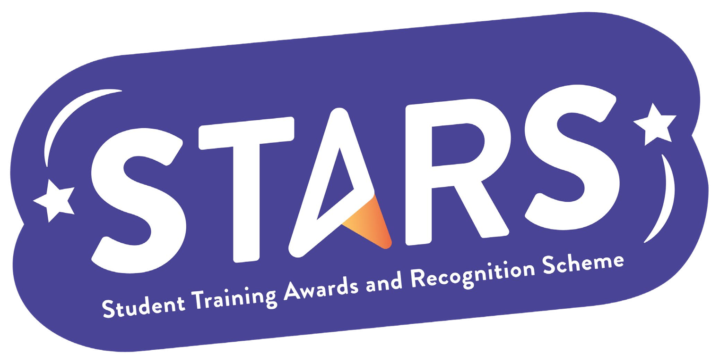

STARS – Engagement

Name of Club/Soc: Insert your Club/Soc name

To achieve this badge, you will need to complete at least 2 of the criteria.
Criteria | Description  (Please describe how your group has met this criteria) | Evidence  (Please include photos, screenshots, social media posts, advertisements etc.)
All core committee members to attend an LSESU Student Leaders Conference
Run a Sheffield Street stall promoting your Club/Society
Submit a termly SU feedback form (by the end of Dec & March)

