
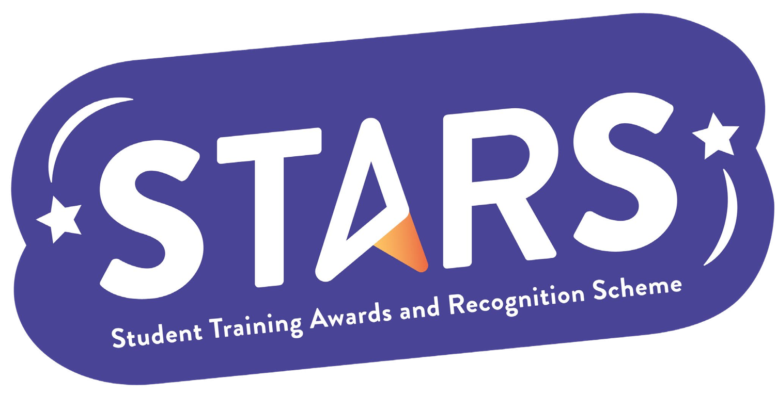

STARS – Inclusion

Name of Club/Soc: Insert your Club/Soc name

To achieve this badge, you will need to complete at least 2 of the criteria.
Criteria | Description  (Please describe how your group has met this criteria) | Evidence  (Please include photos, screenshots, social media posts, advertisements etc.)
Host a free event aimed at demographics underrepresented in your Club/ Society
Introduce a buddy or peer-mentoring scheme in your group with a focus on inclusion and community building (rather than professional development)

Run a Welcome Back GIAG session in January

Run a wellbeing initiative in Autumn Term and Spring Term

