
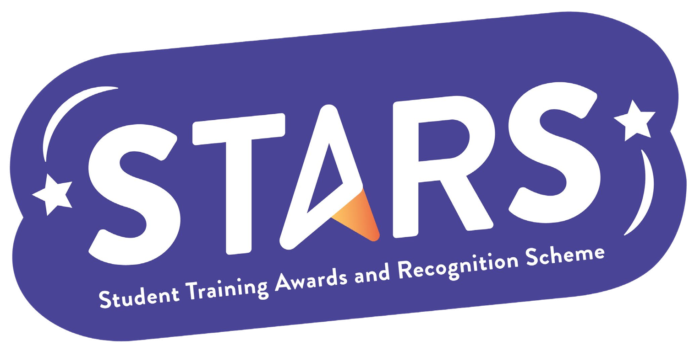

STARS – Social Media

Name of Club/Soc: Insert your Club/Soc name

To achieve this badge, you will need to complete at least 2 of the criteria.
Criteria | Description  (Please describe how your group has met this criteria) | Evidence  (Please include photos, screenshots, social media posts, advertisements etc.)
Create a promotional video/reel of your group and post this to social media

Repost LSESU’s campaigns onto your social platforms
(e.g. Instagram, WhatsApp, LinkedIn)

Your Club/Society is featured on LSESU’s Instagram (@lsesu) post or story

