
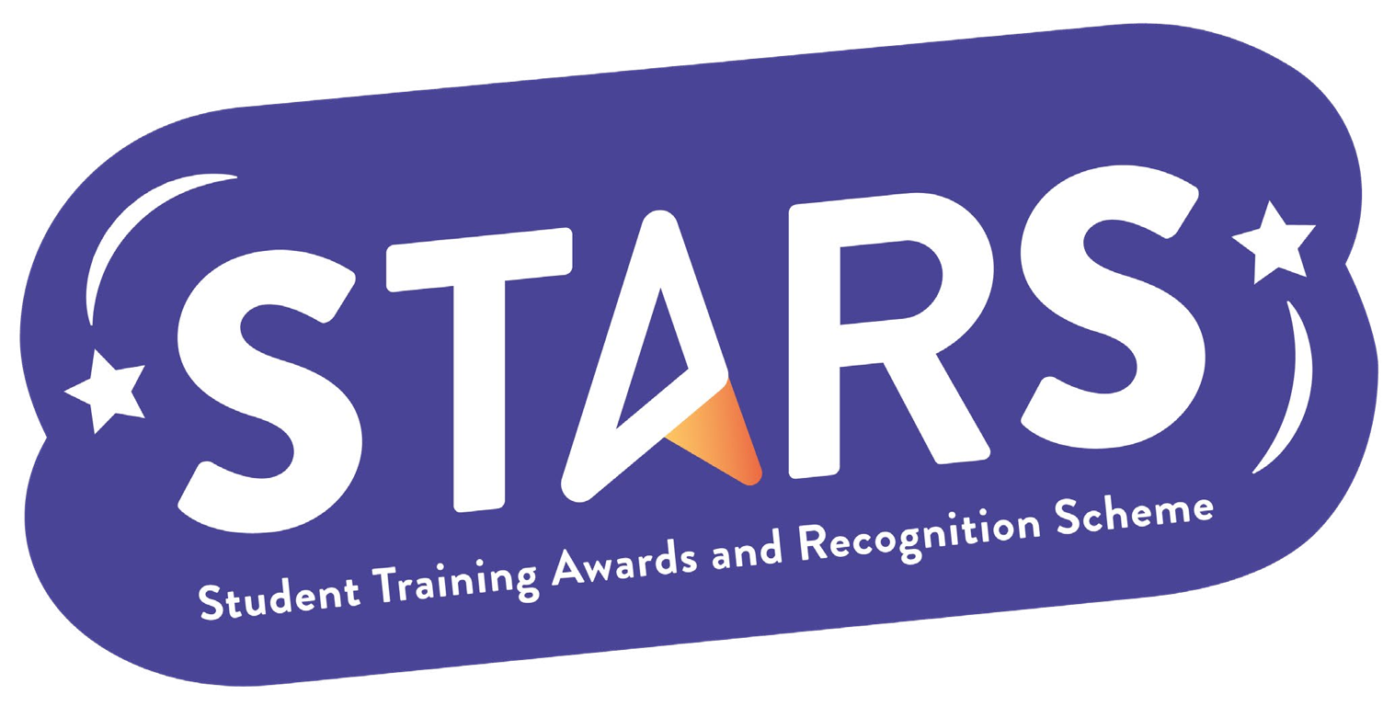

STARS – Sustainability

Name of Club/Soc: Insert your Club/Soc name

To achieve this badge, you will need to complete at least 1 of the criteria.
Criteria | Description  (Please describe how your group has met this criteria) | Evidence  (Please include photos, screenshots, social media posts, advertisements etc.)
Host an event celebrating LSE’s Green Week
Run an event centred around sustainability

