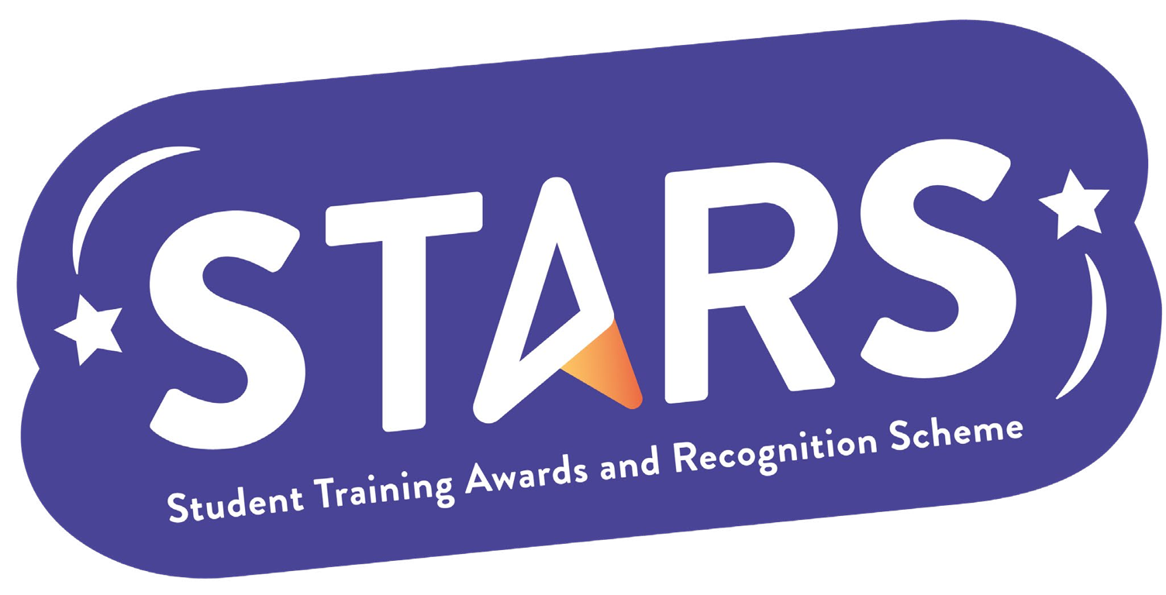

STARS - Bronze Award

Name of Society:

Criteria | Description  (Please describe how your group has met this criteria) | Evidence  (Please include photos, screenshots, social media posts, advertisements etc.)
INFORMED
Have all committee members complete all compulsory online training, gain admin rights, and complete ConsentEd training.
COMMUNITY
Host regular social events (at least once a month during term time) to build a community within your society/club.
COLLABORATION
Collaborate on an event with another society/club that is unrelated to your own.
INCLUSION
Host a Give It A Go event during the start of term (or within a month of your group being set up, if you are a new group)

MARKERS NOTES:

Criteria | Met? (Y/N) | Notes
Informed
Community
Collaboration
Inclusion

