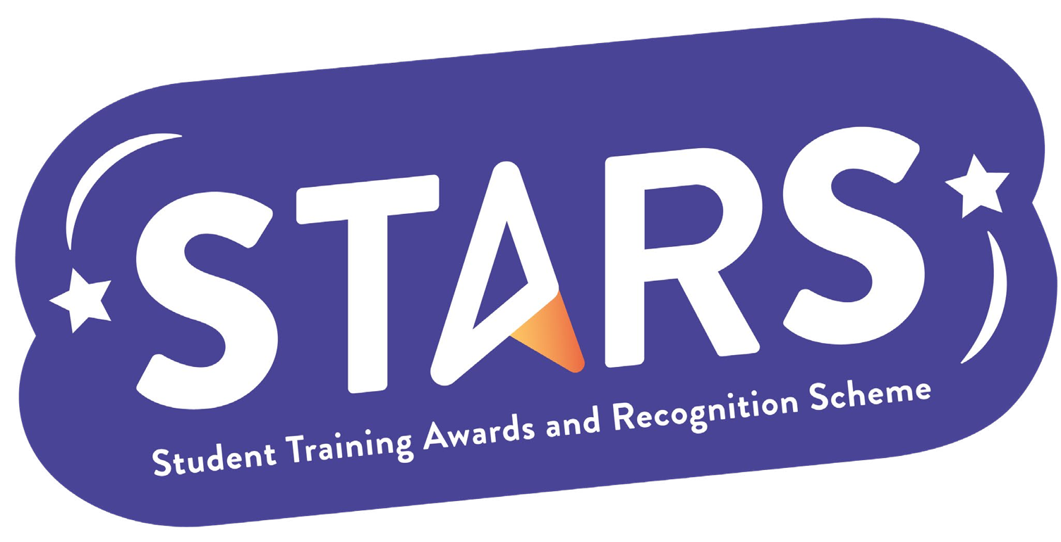

STARS - Gold Award

Name of Society:

Criteria | Description  (Please describe how your group has met this criteria) | Evidence  (Please include photos, screenshots, social media posts, advertisements etc.)
INFORMED
Maintain an up-to-date page on the LSESU website, and have an active online presence on at least two digital platforms (e.g. blog, newsletter, social media etc)
COMMUNITY
Organise at least one fundraising event or a fundraiser for a charity.
COLLABORATION
Take part in or collaborate with the Students’ Union during a campaign or an initiative. (e.g. Black History Month, Active Lifestyle etc.)
INCLUSION
Introduce a buddy or peer-mentoring scheme in your group - with a focus on inclusion and community building (rather than professional development)

MARKERS NOTES:

Criteria | Met? (Y/N) | Notes
Informed
Community
Collaboration
Inclusion

