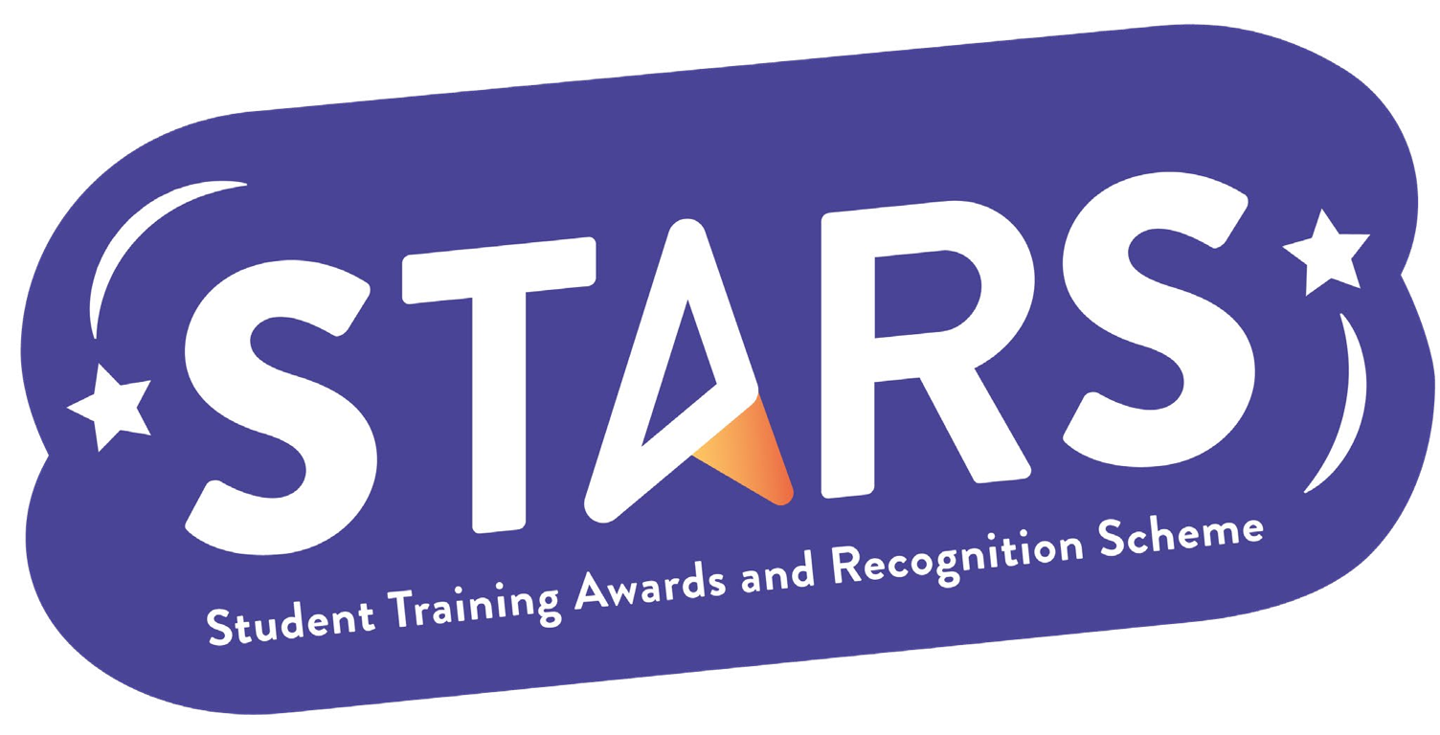

STARS - Silver Award

Name of Society:

Criteria | Description  (Please describe how your group has met this criteria) | Evidence  (Please include photos, screenshots, social media posts, advertisements etc.)
INFORMED
Collect feedback from members, and utilise that to influence the direction of your society.
COMMUNITY
Host a one-off (or regular) volunteering session as a society.
COLLABORATION
Collaborate with an external organisation to host an event/initiative that benefits your members.
(E.g. a speaker event, or networking activity)
INCLUSION
Host one event that focuses on the empowerment of marginalised student groups. (This should be educational AND celebrate a group’s achievements, culture, and history)

MARKERS NOTES:

Criteria | Met? (Y/N) | Notes
Informed
Community
Collaboration
Inclusion

