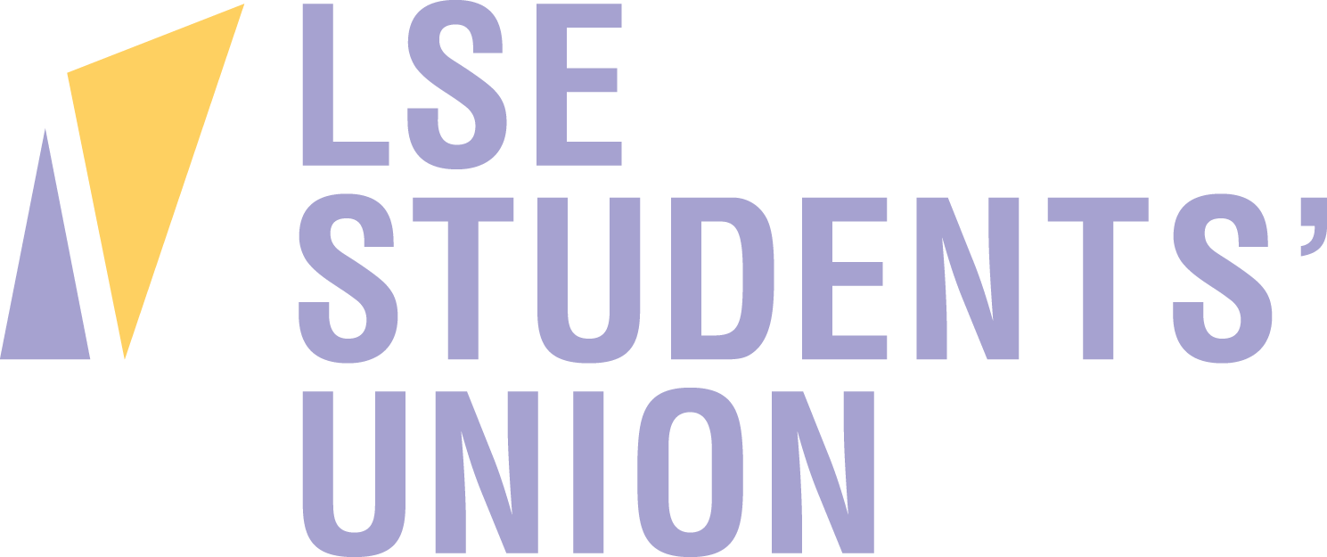

Communications Assistant (Writer)

Accountable to: LSESU Communications Coordinator
Salary: London Living Wage - £9.40 per hour
Hours: 5 - 15 hours per week
Location: Saw Swee Hock Student Centre

LSESU is looking for an organised and enthusiastic student with exceptional writing skills to join our Communications team on a part-time basis.

In this role you’d spend most of your time writing content for our Tumblr blog - which could be on just about any assigned subject! The task could be to attend an event and write it up as a blog, to interview somebody or could involve researching a specific area to provide students with handy info.

You may also get to work with our Elected Officers on creating written content to promote their campaigns and activism - delivering change where it matters!

To be an ideal candidate for this fun position you need to have a passion for writing, good knowledge of the English language/grammar, Tumblr know-how and be able to write quickly in a friendly, accessible manner.

If your application is successful, you will create original content that reflects your perspective as an LSE student, contribute to our social media output, and play an integral role in building the student community for 2016-17.

The ideal candidate will have:
- Great written and verbal communication skills
- Work effectively as part of a team
- The ability to work efficiently to a deadline
- Experience writing blogs and articles
- The ability to adapt tone and style of writing to suit audience and subject
- An interest in social media, particularly blogging
- The ability to work without supervision and using own initiative

Responsibilities:
- Working to a brief and delivering online content efficiently to a deadline
- Review performance of content to continually ensure engaging content is created and shared
- Following LSESU’s comms guidelines
- Proactively reporting back to Communications Coordinator
- Feeding back insights to the Communications team

Before you submit your application, we recommend you check out our different communications channels:
- Website: lsesu.com
- Blog: lsesu.tumblr.com
- Twitter: twitter.com/lsesu
- Facebook: facebook.com/lsesu
- Instagram: instagram.com/lsesu

Please apply using the Student Staff Application Form and Equal Opportunities Form provided and email it to su.jobs@lse.ac.uk

Closing date: 25th July
Interview date: 28th July

LSESU is committed to fully representing LSE’s diverse student community, and we welcome applicants from all backgrounds.

